PROJECT DOCUMENTATION:
WEBSCRAPING AFTER EXPLORATORY DATA ANALYSIS USING PYTHON AND MACHINE LEARNING
TITLE: COSMETIC DATASET
NAME: INDRARAJA.S
COURSE: DA/DS
BATCH : JUNE-2025

INTRODUCTION:
The Cosmetic Dataset contains detailed information about various grocery products, including their pricing, category, ratings, and discount details. It is designed to analyze sales trends, pricing strategies, and product performance in a retail or supermarket setting. Here columns includes:
- Product_name
- Price
- Rating
- MRP
- Discount

Objective:
The main goal of analyzing this dataset is to:

- Identify which products and categories attract the most discounts.
- Understand how Price, MRP, and Discount interact.
- Predict future discounts or classify products based on pricing and sales performance.
- Support data-driven retail decision-making for profit optimization.

PROBLEM OF STATEMENT :
- This project uses grocery product data to study how price and rating affect discounts.
- Using machine learning, it predicts the discount for each product.
- The goal is to help improve pricing and sales decisions.
PROJECT WORKFLOW:
1)Problem Definition
Define the aim:To develop a machine learning model that predicts the discount of grocery items using data by analyzing factors such as product_name, price, mrp, and rating.
2)Data Understanding
Explore dataset structure, features, and target variable (Discount).Identify data types, distributions, and missing values.

3)Webscraping:
- We collect grocery item details (name, price, brand) from websites automatically.
- The code reads the website page and picks only the important details like price, offers, and quantity.
- All the collected data is saved in a file so we can study prices and compare products later.
4)Data Preparation
- Removed unnecessary or duplicate columns.
- Clean and convert numeric columns safely.
- Trimmed extra spaces and standardized all text data to lowercase or uppercase.
- Dropping rows with missing essential match data.
5)Exploratory Data Analysis (EDA):
- Visualize discount patterns by price, mrp, and rating.
- Find correlations between features and discount.
6)Conclusion & Insights
- Summarize key discount factors.
- Highlight the best-performing predictive model.
DATA UNDERSTANDING:
- In the data understanding step, we explored the grocery dataset to know its structure, columns, and data types.
- We checked the number of rows, missing values, and sample records.
- This helped us understand what kind of data we have before doing analysis or model building.

DATA CLEANING:
- In the data cleaning step, we removed unwanted or missing values from the dataset.
- We checked for duplicates, corrected data types, and ensured all values were in proper format.
- This made the data ready for analysis and model training.
OUTLIER TREATMENT:
- In the outlier treatment step, we identified values that were too high or too low compared to the rest.
- These outliers were handled by removing or adjusting them to keep the data consistent.
- This helps improve the accuracy of the model and avoid wrong predictions.
HANDLING INCONSISTENT VALUES:
- Remove unwanted spaces, special characters, or extra symbols.
- Use mapping dictionaries or Label Encoding for standardization.
- Verify cleaned data for uniformity.
- Ensures accurate, reliable, and consistent Discount data analysis.

FILTERING DATA FOR ANALYSIS:
- Filtering data means selectinSelected only the important columns like price,rating,MRP and discount
- Removed unwanted or repeated product entries.
- Filtered out missing or incomplete data rows.
- Keep only relevant records useful for prediction and analysis.
- Ensured all values were in the correct format for modeling.
- Finalized a clean and focused dataset for better results.
EXPLORATORY DATA ANALYSIS (EDA):
Libraries For Visualization:
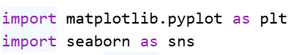
Univariate Analysis:
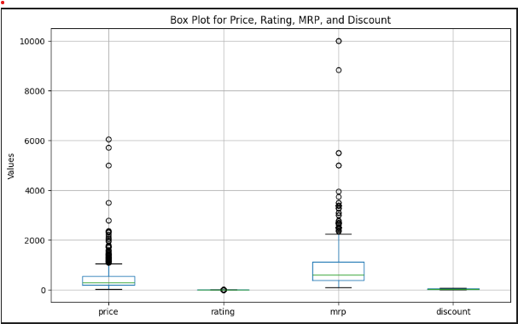
Insights:
- Some products have a very high price or MRP compared to others. These are shown as dots far from the main group.​
- Most products have ratings that are close to each other. There is hardly any difference in ratings.​
- Discounts for most products are very small. The line is almost flat, showing most items don't get big discounts.
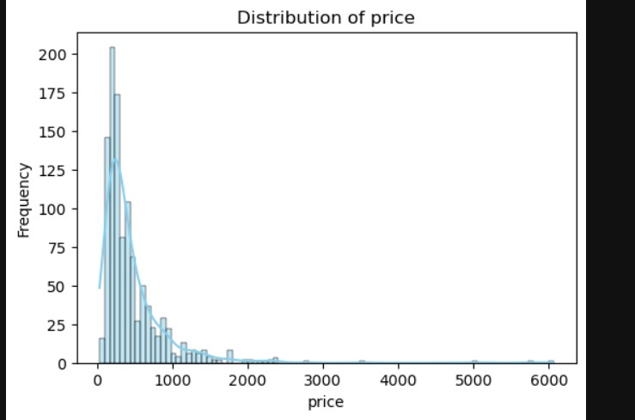Insights:
- Most products have prices below 1000, which means cheaper items are more common.
- Very few products have prices above 2000, showing that expensive items are rare.​
- The price distribution is heavily skewed to the left, meaning most sales happen for low-priced products.​
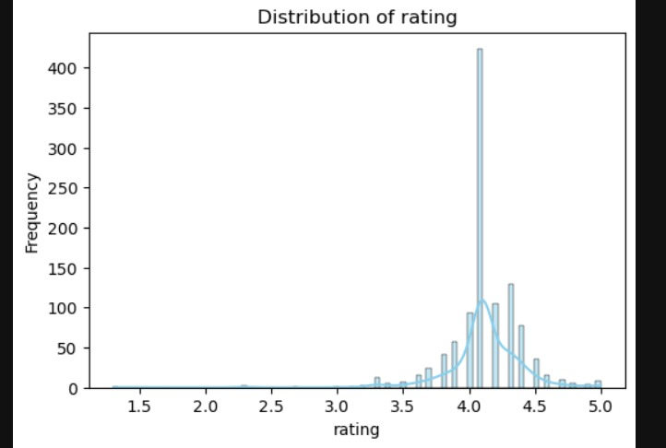Insights:
- Most products have an MRP below 1000, which means lower-priced items are very common.​
- Only a few products have very high MRP above 2000 or even much higher, showing that expensive items are rare.​
- The chart is skewed to the left, meaning almost all products are in the lower price range for MRP.​
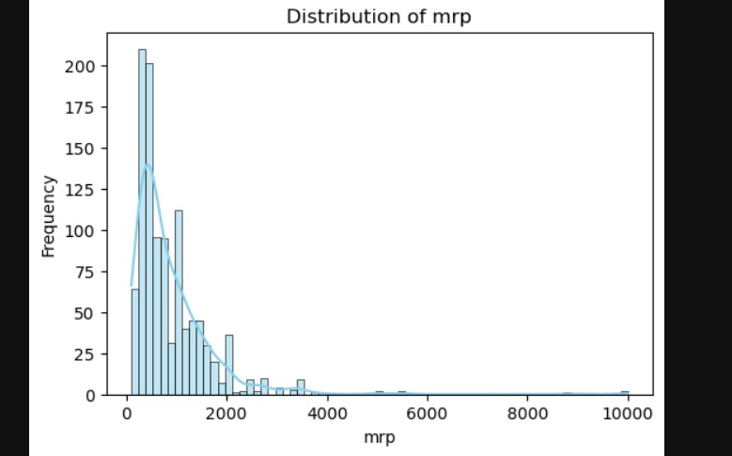Insights:
- Discounts are spread out over many values, meaning products get a wide range of discounts, not just one fixed amount.​
- Most products have discounts between 10% and 60%. These ranges are the most common among all items.​
- High discounts (above 80%) and very low discounts (less than 10%) are less frequent, so they’re more rare.
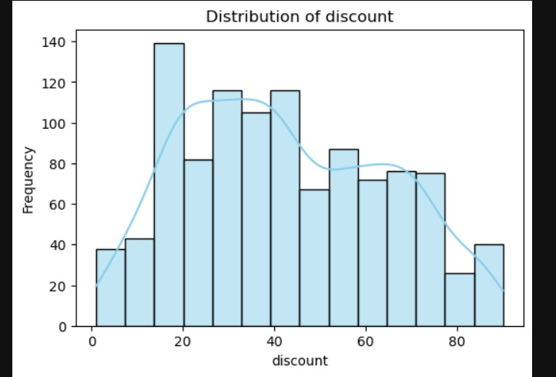
Insights:
- Most products, no matter the price, have ratings between 3.5 and 5.​
- Products with lower prices (below 2000) show more variety in ratings, from 2 up to 5.​
- As the price increases above 2000, product ratings stay steady and high (close to 4).
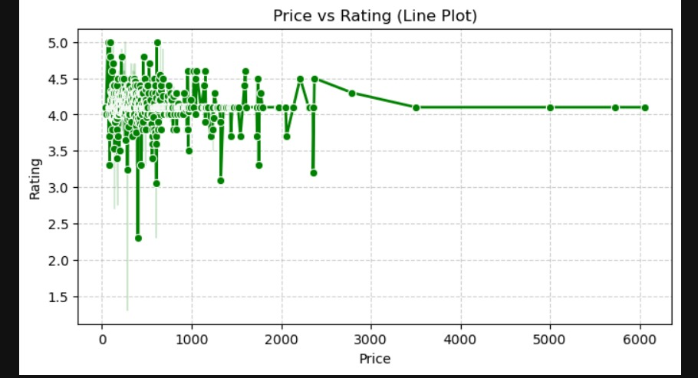Insights:
- Price and MRP go up together: Higher price products usually have higher MRP values too.​
- Most products are grouped at the lower end (both price and MRP are less than 2000).​
- There are some products far away from the main group, showing a few items with very high price and MRP.
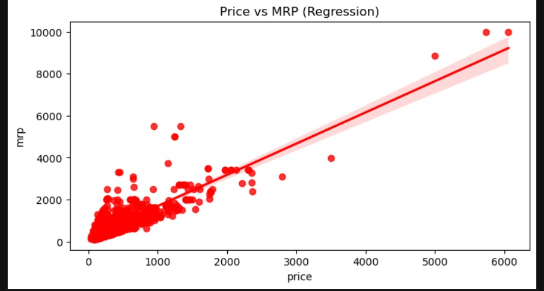Insights:
- Most products (dots) are clustered at lower MRP values (less than 2000), and these have a wide range of discounts.​
- Products with very high MRP (above 6000) are rare, but they can still get large discounts.​
- There is no clear relationship between MRP and discount; products with both low and high MRP show all kinds of discounts.​
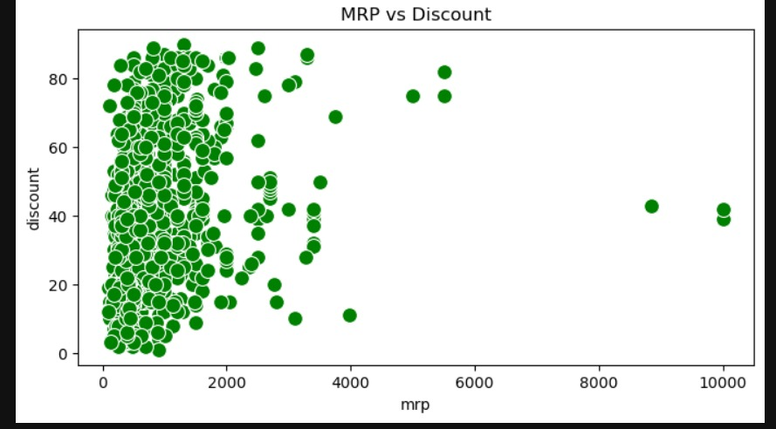Insights:
- Price and MRP have a strong positive relationship: As price increases, MRP increases too.​
- Discount values are spread widely and do not show a strong connection with price, rating, or MRP.​
- Ratings mostly stay between 3 and 5 for all products, regardless of price, MRP, or discount.
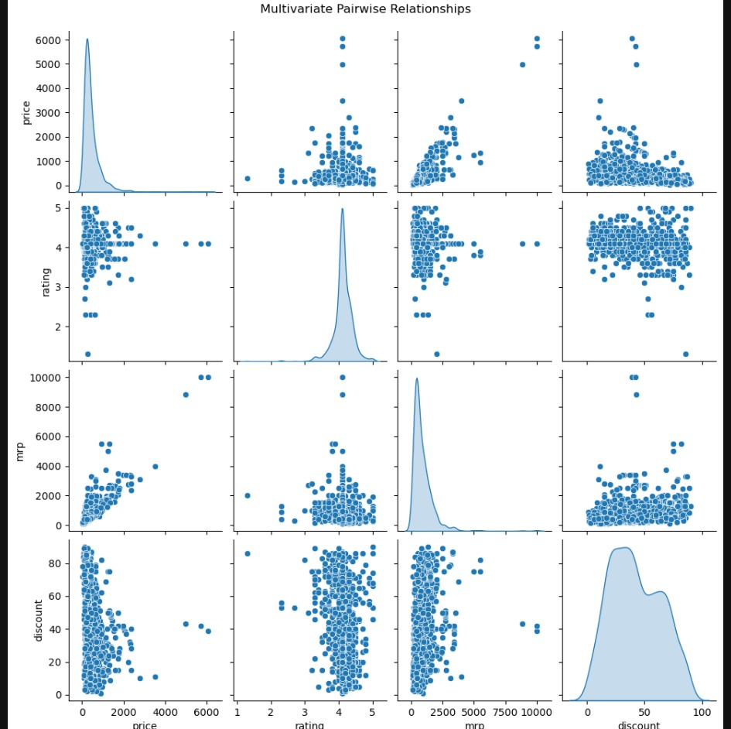Insights:
- Price and MRP have a strong positive relationship (correlation value is 0.84), so they usually go up together.​
- Rating has a weak connection to other variables (values close to zero), which means ratings don’t depend much on price, MRP, or discount.​
- Discount has a small positive relationship with both MRP and price, but it’s not strong (values around 0.17 and 0.26).
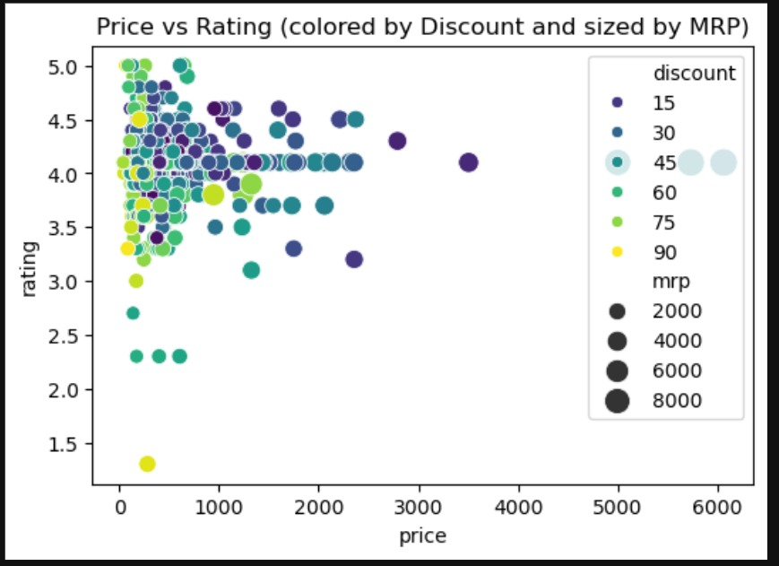Insights:
- Most products have prices below 2000 and ratings above 3.5, seen by the cluster of points in the left top part.​
- Products with different discounts (color) and MRP (size) are spread, showing no strong pattern between these features and rating.​
- Even high-priced items (right side) still get good ratings, but they are fewer in number compared to low-priced ones.​
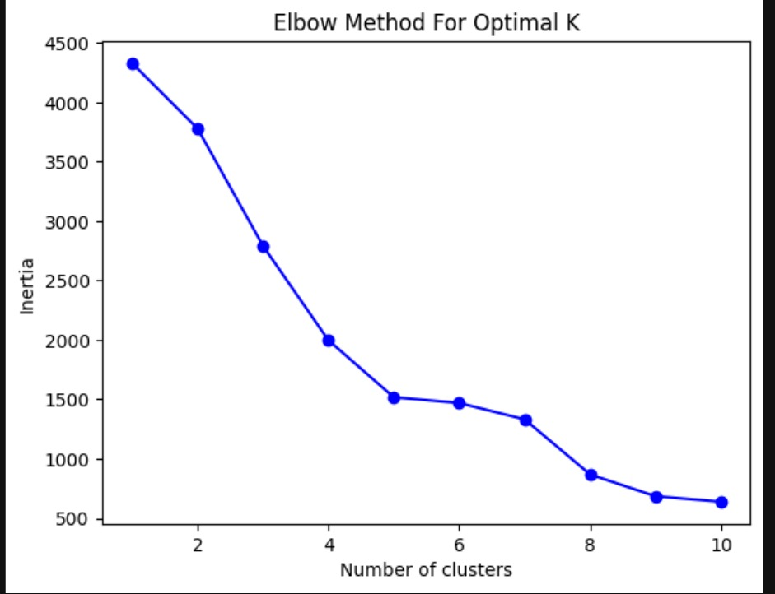Insights:
- The curve drops quickly first and then flattens, helping to spot the best number of clusters.​
- The "elbow" appears close to K = 4, meaning grouping the data into 4 clusters is a good choice.​
- Using more than 4 clusters does not reduce inertia much, so it's not very useful for your data.
Insights:
- XGBoost and Random Forest models perform the best, with all scores (accuracy, precision, recall, F1) close to 1.​
- The KNN model gives good results, but not as high as XGBoost or Random Forest.​
- SVM and Logistic Regression have much lower scores across all metrics, so they are not as effective as the other models here.​

MACHINE LEARNING MODEL
SMOTE:
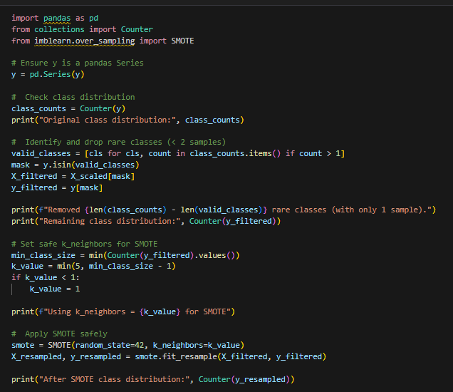

Import ML libraries:
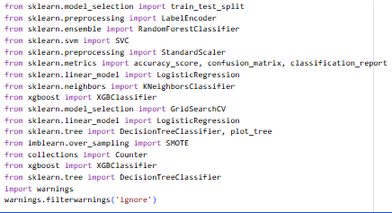
Encode Categorical Variables
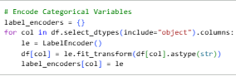
Train-Test Split:
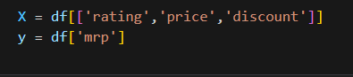
Random Forest Classifier:
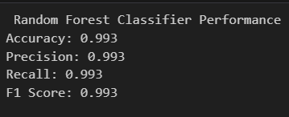
SVM
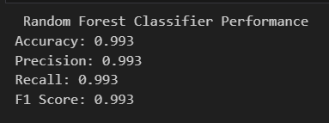
Logistic Regression:
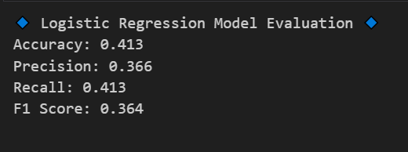

KNeighbors Classifier:
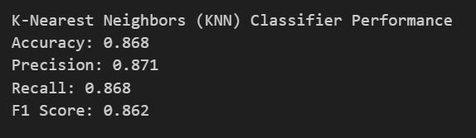
Xgboost:
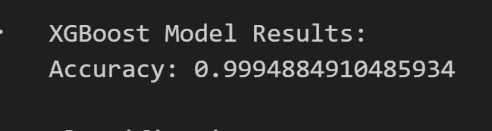
HYPERPERAMETER TUNING:
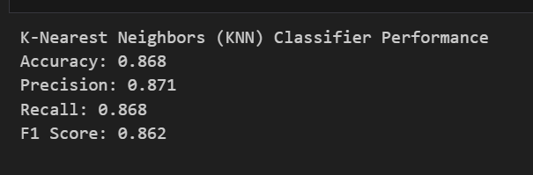

MODEL COMPARISON:
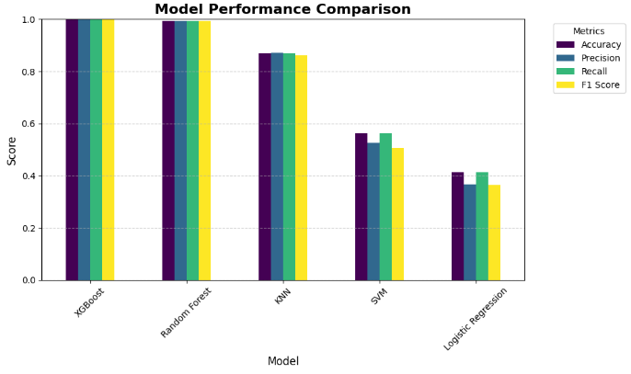
SQL CONNECTIVITY:

CONCLUSION:
- Most products are low-priced (below ₹1000), making the catalog largely budget-friendly.
- Very few high-priced items exist, and they appear as outliers with extremely high price/MRP values.
- MRP distribution is left-skewed, meaning almost all products belong to the lower MRP range.
- Product ratings are consistently high, mostly between 3.5 and 5 across all price levels.
- Cheaper products show more rating variation, while expensive products maintain steady ratings around 4.
- Discounts vary widely, but most products fall within the 10%–60% discount range.
- Price and MRP increase together, showing a strong positive relationship between the two.
- No clear link between MRP and discount, meaning products—cheap or expensive—receive all types of discount levels.

